

Name: Tehreem Mirza
Registration no: FA22-BSE-088
Class: BSE-8B
Lab Task 01, 04
Submitted to: Sir Ibrahim

Task 01:
Install Linux On VMware or Virtual box or using WSL on a local PC.
Ubantu Installation Steps:
1: Go to Microsoft store and search ubantu and download the LTS version .
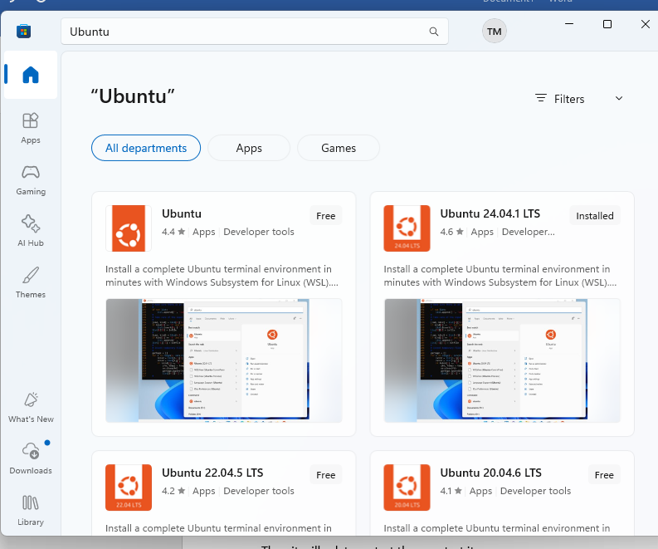

2: Open power shell and type wsl –install.
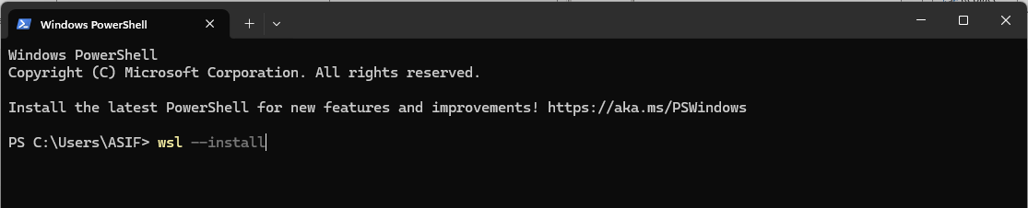

3.open menu and search Turn Windows features on or off and tick these two
- Windows Subsystem for Linux
- Virtual Machine Platform
Then it will ask to restart then re start it.
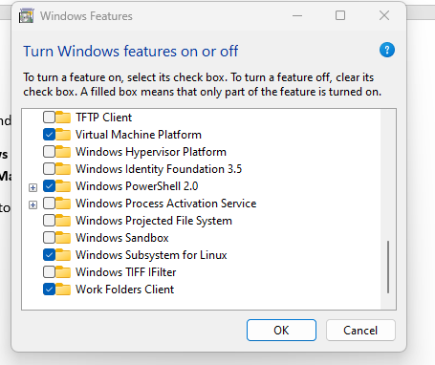

4: then Open ubanto and click on open then terminal will open then add user name and password and password will not show as you see but don’t worry write it.
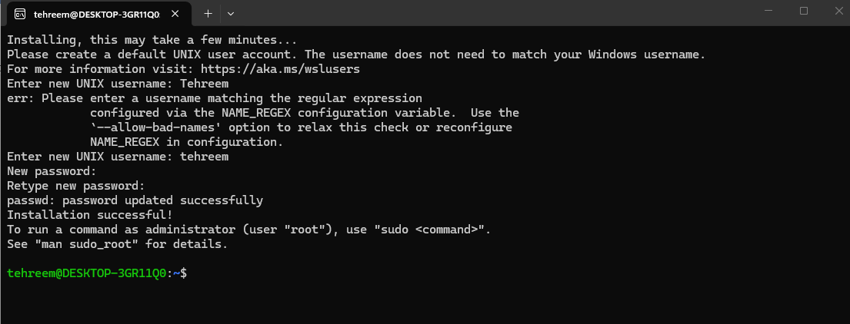
Look now you run commands :
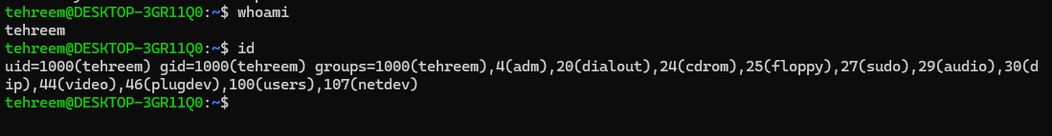

Task 04:
Install Git and create GitHub account and link account with Linux machine via terminal to upload or download repositories from GitHub account.
apply basic commands of Git terminal by following CUI DevOps course Lab Manual.
---Already GitHub desktop , gitbash install is done .. git hub online also account creation is done.

This is commands i run on it .
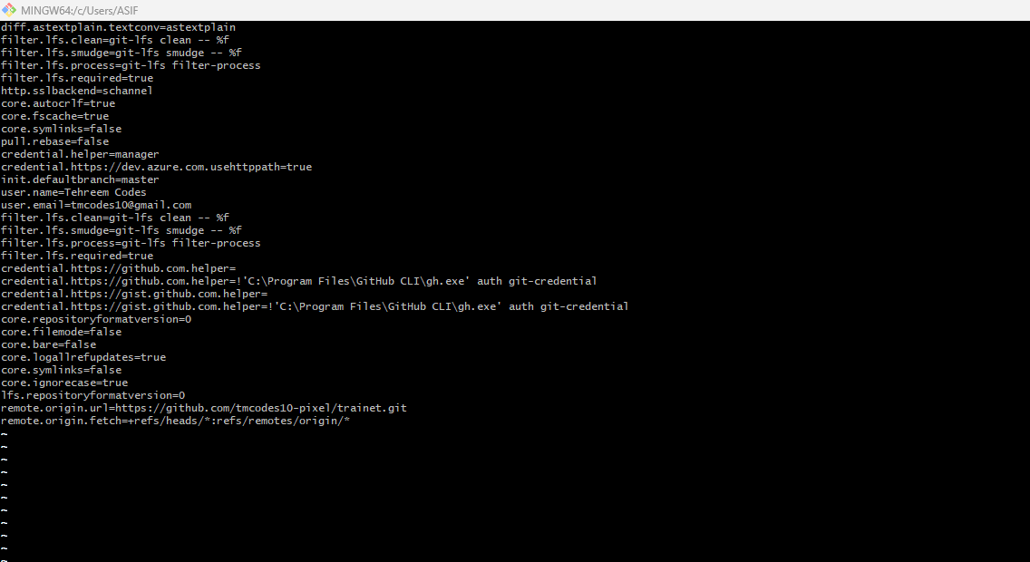

Now adding repository to
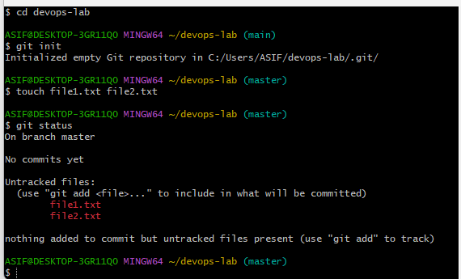

Create repository devops-lab and run these commands:
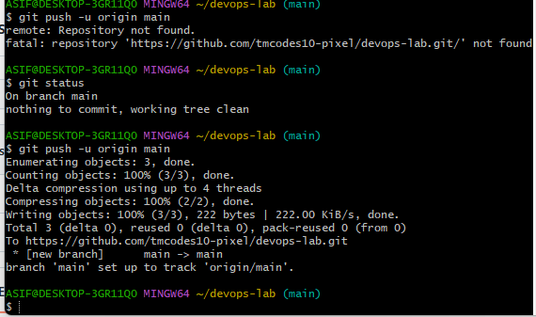

Look these files are now pushed on github.


